## PDF To Text Creation

This document will explain you how to run pdf to text conversion automation.

**Step 1:** Double click on **PdfToTextConvertor.zappy** automation.

**Step 2:** **Run Zappy Task** window will pop up. Now Click on **OK**.

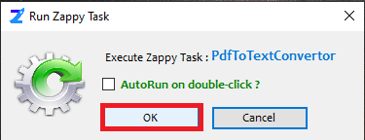

**Step 3:** Zap Automation shows another pop-up window on screen to select pdf document.

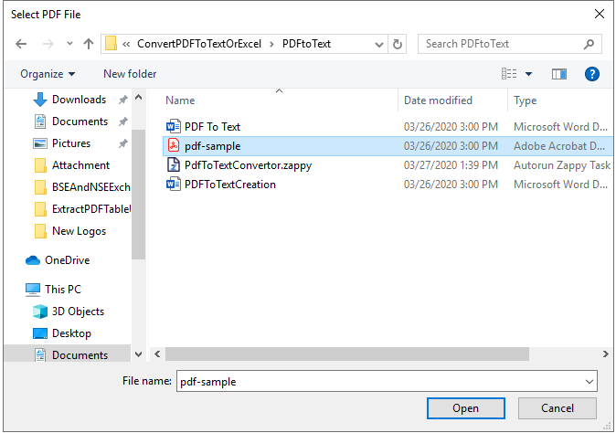

**Step 4:** You can see “**Successfully Executed Task**” at the bottom right corner.

**Output:**

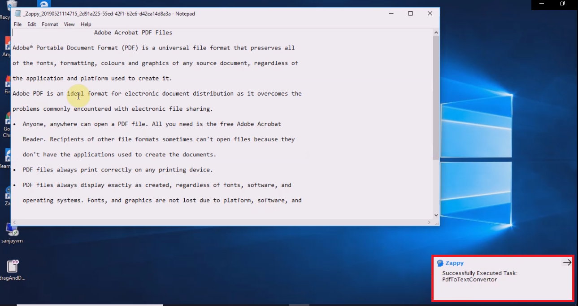

**In this way we can use this automation to convert any pdf file to text file.**